PAMELA PALMER JONES, DMA
1473 East 2300 South, Salt Lake City, UT 84108 (801) 259-5107 pam.jones@utah.edu

EDUCATION AND CERTIFICATION

UNIVERSITY OF UTAH Salt Lake City, Utah
Doctor of Musical Arts
Concentration in Piano Performance/Minor in Music History
Recipient of first DMA degree in piano awarded by the University of Utah
Winner in SummerArts Piano Concerto & Solo Competitions
DMA Thesis: The Fitzwilliam Virginal Book: Historical Background and
Performance Practice Issues

UNIVERSITY OF CALIFORNIA AT LOS ANGELES Westwood, California
Master of Fine Arts (3.5 year terminating degree)
Concentration in Historical Performance Practice, Piano & Harpsichord
MFA Thesis: Performance Practice Issues in Beethoven's Sonata, Op. 109
Recipient of full graduate fellowship & housing stipend at UCLA
First place winner of Concerto, Atwater Kent, and Nancy Kendall Robinson
piano competitions at UCLA

ROYAL COLLEGE OF MUSIC London, England, UK
ARCM (Associate, Royal College of Music) Performers Diploma in Piano
Concentration in Piano Performance, Minor in Harpsichord and Early Music
Recipient of full graduate fellowship, including tuition, room and board, and
airfare to and from the RCM
UNIVERSITY OF UTAH Salt Lake City, Utah
Bachelor of Music, Piano Performance
Two-time Winner of University of Utah Concerto Competition
First place, Mu Phi Epsilon Performance Competition
Awarded Honors at Entrance, Music Department, and Band Scholarships
Nominated to Phi Kappa Phi, Phi Eta Sigma, and Beehive Honor Society

NCTM (Nationally Certified Teacher of Music) CERTIFICATION St. Louis, Missouri
Permanent professional certificate awarded by the Music Teachers
National Association based primarily on peer review of candidate’s teaching
and pedagogical skills.

PIANO EXAMINER, ROYAL CONSERVATORY OF MUSIC (RCM) USA & Canada
Professional Adjudicator and member of the College of Examiners
(Piano) for the Royal Conservatory of Music in Canada, USA, &
Hong Kong since September 2021.

TEACHING AWARDS & FELLOWSHIPS
UNIVERSITY OF UTAH 2016-2017
- College of Fine Arts Faculty Excellence in Teaching Award,
given in recognition for (1) creating innovative teaching tools that
strengthened learning outcomes for undergraduate theory/musicianship
students, (2) outstanding mentoring of theory & musicianship TAs
(including a University TA Scholar), (3) overseeing and enhancing the
Musicianship program & curriculum, (4) serving on numerous MMus
and DMA committees, and (5) working with students as faculty advisor
for the Baroque Student Group in obtaining FAF grants.

SALT LAKE COMMUNITY COLLEGE 2011-2012
- Fellowship, Adjunct Faculty Academy, Salt Lake Community College,
one of 20 adjunct professors competitively selected for the first SLCC Adjunct Faculty Academy cohort. Completed 25 hours of intensive faculty development courses, including active-based learning strategies for the classroom, student engagement techniques, and high tech skills.

RESEARCH

THE CASTRUCCI PROJECT - WORLD PREMIER RECORDING OF OP. 1 2021-2022
This is the introductory trailer announcing the world premier recording of all twelve Op. 1 Sonatas by Pietro Castrucci (1679-1752), performed by Gerald Elias (violin), Pamela Palmer-Jones (harpsichord) and Noriko Kishi (cello). Castrucci, a protégé of the great violinist and composer Arcangelo Corelli, was also concertmaster for Handel’s London opera orchestra in from 1718 until 1737. Though his published output is modest, his known compositions demonstrate a complete mastery of his craft and a distinctive and dramatically expressive voice. This historically informed performance project was generously funded through University of Utah Teaching Grand & Research Grant awards, as well as with private donations via a GoFundMe campaign.

The complete Op. 1 recording is available from Centaur Records as a 2-CD set at https://www.amazon.com/dp/B09T77XL2D]and is downloadable on all major platforms.
Castrucci Op. 1 Trailer: https://youtu.be/o2j3pmFFaaY
Castrucci Op. 1 Research Overview: https://youtu.be/Pq4k8l_cgxI

FACULTY APPOINTMENTS AND ASSIGNMENTS

PROFESSOR (LECTURER) 2020
SCHOOL OF MUSIC, THE UNIVERSITY OF UTAH

ASSOCIATE PROFESSOR (LECTURER) 2015-2019
SCHOOL OF MUSIC, THE UNIVERSITY OF UTAH

ASSISTANT PROFESSOR (LECTURER) 2013-2015
SCHOOL OF MUSIC, THE UNIVERSITY OF UTAH
ADJUNCT ASSISTANT PROFESSOR 2012-2013
SCHOOL OF MUSIC, THE UNIVERSITY OF UTAH

ASSOCIATE INSTRUCTOR 2009-2012
SCHOOL OF MUSIC, THE UNIVERSITY OF UTAH
ADJUNCT PROFESSOR/ PIANO, MUSIC APPRECIATION, THEORY 2004-2014
SALT LAKE COMMUNITY COLLEGE

PROFESSOR/PIANO 2002-2003
HARPER COLLEGE & HARPER MUSIC ACADEMY (Chicago)

ADJUNCT PROFESSOR/PIANO, MUSIC APPRECIATION, THEORY 1997-2003
COLLEGE OF LAKE COUNTY (Chicago)

Course professor for the following classes at the University of Utah:
- MUSC 1110 (Music Theory I)
- MUSC 1120 (Music Theory II)
- MUSC 1130 (Musicianship I)
- MUSC 1140 (Musicianship II)
- MUSC 1941 (Undergraduate Private Applied Lessons/Piano)
- MUSC 1943 (Undergraduate Private Applied Lessons/Harpsichord
- MUSC 1993 (Undergraduate Private Applied Lessons/Harpsichord)
- MUSC 2130 (Musicianship III, and Advanced Musicianship III)
- MUSC 2150 (Class Piano III)
- MUSC 2140 (Musicianship IV and Advanced Musicianship IV)
- MUSC 3560 (Theory V - Form and Analysis)
- MUSC 437/4437/6437 (Early Music Ensemble Co-Director)
- MUSC 6910 (Individual Research)
- MUSC 7210 (Doctoral Performance Practice 1600-1750)
- MUSC 7211 (Doctoral Performance Practice 1750-1900)
- MUSC 7191 (Doctoral Private Applied Lessons/Harpsicord)
- MUSC 7xxx- Doctoral Harpsichord Lit I
Instructional software used extensively in these courses including
PowerPoint, Amadeus Pro, Finale, iMovie & QuickTime. MUSC 3540,
7210, and 7211are taught as flipped courses.

Co-Director of University of Utah Early Music Ensemble (with Professor Lisa Chaufty) 2022-
Trailer (created by Pam Jones): https://youtu.be/dZqoErtXXk4
Coordinator for Aural Skills & Musicianship/TA Supervisor, University of Utah 2009-2022
- Responsibilities include mentoring of TAs, weekly area
meetings, class observations, aural skills pedagogical training,
and teaching of classroom management skills.
Coordinator for Class Piano/TA Supervisor, University of Utah 2009-2012
- Responsibilities included mentoring of TAs, bi-weekly
meetings, class observations, pedagogical training, and teaching
of classroom management skills.
- In charge of all testing & updating of Class Piano curriculum

DEE GRANT, UNIVERSITY GRANTS, TRAVEL FUND AWARDS

Dee Grant Award [with Vedrana Subotic] ($10,000) 2022
- For Artist-in-Residence Christopher O'Riley. Schedule included 8
lectures, 8 masterclasses, a competition "Bach to Community via
video submission, and four concerts of performing Bach's entire "Well-
Tempered Clavier, Books1 & 2" with Mr. O’Riley, U. of U. Keyboard
faculty and students. Website: https://www.allaboutbach.org/

University Research Grant [URG] ($5100) 2021
- Awarded March 2021 for the Pietro Castrucci Op. 1 World Premier
Recording & Edition Project.
University Teaching Grant [UTG] ($3500) 2020
- Awarded December 2020 for the Historical Performance Practice
Pedagogical Videos Recording Project
Dean's Travel Fund Award ($1050) 2020
- For airfare & hotel expenses - refereed lecture presentation for the
MTNA(Music Teachers National Conference)National Convention
in Chicago, Illinois.
Dee Grant Award ($4744.40) 2019
- For Artists-in-Residence Dr. Kenneth Drake, fortepiano, and Jun-Hee Han, fortepianist & conductor. Hotel & travel expenses, & fee for seven class lectures, a piano masterclass, and two concerts.

Dean's Travel Fund Award 2017
- For travel expenses to give a presentation & concert performance of a
harpsichord concerto with the Los Angeles Valley Orchestra.
University Teaching Grant 2013
- Sibyl of the Rhine: The Art, Music, & Poetry of Hildegard von Bingen" Master Class/Lecture Concert with Early Music Specialist Shulamit Kleinerman for the University of Utah Women's Week.

SERVICE TO THE SCHOOL OF MUSIC & COLLEGE OF FINE ARTS

- Member of College Council 2020-2022
- Facilitated the donation of a practice harpsichord to the SOM 2021
from the Cannon Family Trust
- College Council Career Line Representative 2020-2022
- Theory Search Committee 2018
- 20th/21st Century Musicology Search Committee 2015
- Pre-1750 Musicology Search Committee 2015
- Pre-1750 Musicology Search Committee 2014
UNIVERSITY OF UTAH TEACHING SUPPORT OF STUDENTS OUTSIDE OF THE CLASSROOM

FACULTY ADVISOR FOR STUDENT GROUPS
- UTAH CHAMBER ENSEMBLE 2018-2019
I served as the Faculty Advisor for this 20-piece chamber orchestra,
an undergraduate student- run organization that was registered through
STUDENT.ORGS (Student Leadership & Involvement) on campus.
- UNIVERSITY OF UTAH STUDENT CHAPTER, UMTA 2014-2016
During my time as faculty advisor, our chapter vice president, Desiree
Gonzales, received the award of "UMTA Student Teacher of the Year"
in October of 2014. Additionally, I facilitated funding through CFA
and MTNA for two of our DMA students (Desiree Gonzales and
Christie Sowby) for travel to Texas and Scotland to present a joint piano
pedagogy research paper.
- UNDERGRADUATE BAROQUE STUDENT GROUP 2014-2015
Faculty advisor and coach for this student-run group who presented
three concerts. Membership in the group grew steadily during my
three semesters of advising the group, from four members up to fifteen.
INSTRUCTOR (UNPAID TEACHING OVERLOAD) FOR DMA INDIVIDUAL RESEARCH
- Lewis Quinn (MUSC 6910) 2013-2014
- Sidnei Alferes (MUSC 6910) 2014
- Ke An (MUSC (MUSC 7191) Spring Semester 2021

FACULTY MEMBER OF GRADUATE COMMITTEES
- Ke An, piano Projected graduation date 2023
- Patrick Tatman, DMA choral conducting Projected graduation date 2022
- Dan White, choral conducting Projected graduation date 2021
- Daniel Tselyakov, DMA piano Projected graduation date 2021
- Hung-Yang Lin, DMA violin 2020
- Nick Harker, DMA conducting 2020
- Anthony Buck, DMA voice 2018
- David Hall, DMA saxophone 2018
- Claudia Restrepo, DMA conducting 2017
- Christie Sowby, DMA piano 2017
- Alyssa Young, MM piano 2017
- Michael Green, DMA piano 2016
- Katherine Chipman, MM Music History and Literature 2016
- Sidnei Alferes, DMA voice 2016
- Garrick Woods, DMA cello 2016
- Lewis Quinn, DMA voice 2014
- Jamilyn Morris, DMA cello 2013
FACULTY MENTOR FOR University of Utah TA SCHOLAR DEVIN MAXWELL
- Project: "Ascolta cantare 1.0: Software to Enable Group Musicianship 2013
Exercises for Accelerated and More Comprehensive Development of
Fundamental Aural Skills"
ORGANIZED STUDENT PERFORMANCE OPPORTUNITIES
- EARLY MUSIC AMERICA YOUNG PERFORMERS FESTIVAL 2021
AWARD. This was a collaboration between students in my
Doctoral Performance Practice Seminar and the U. of U. Early
Music Ensemble, directed by Professor Lisa Chaufty. Our submission
was one of 14 institutions from North and South America chosen
to participate in this prestigious annual event:
https://www.earlymusicamerica.org/2021-virtual-young-performers-festival/
- Harpsichord coach for Early Music Concert "Musical Journeys through 2021
Time and Place in Thompson Chamber Hall"
- Organized and rehearsed for a collaborative concert tour featuring our 2020
doctoral MUSC 7211 students and faculty of Dixie State University and
Southern Utah University. The tour was cancelled by our university one
week before the March 11 & 12 concerts, due to the Covid-19 pandemic.
- Organized two concerts in for SOM students, faculty, & guests 2019
to perform in two concerts with 2019 Dee Grant fortepianists Dr.
Kenneth Drake and Jun-Hee Han. Participating students included
nine members from my MUSC 7211 Doctoral Performance
Practice Seminar, the U. of U. Graduate String Quartet, and the Utah
Chamber Ensemble, a student-run classical orchestra of about forty
players. A 10-minute video compilation that I created, showcasing
performances from both concerts can be accessed here: https://youtu.be/_ZlF4zrnyo4
- Collaborated with Professor Lisa Chaufty to plan a concert for the Music 2019
Advisory Board Early Music, performed by members of the Doctoral
Performance Practice and Early Music Ensemble classes.
- Helped plan & facilitate a faculty/student Baroque concert at the Utah 2019
Museum of Natural History with Professor Lisa Chaufty that included
several undergraduate and graduate students from the SOM.
- Facilitator for organizing fortepianist Dr. David Kim's 4-day residency 2018
at the SOM, including a Fridays w/Faculty lecture, two masterclasses,
lecturing to the music history and doctoral performance practice courses,
and a solo recital in Thompson Chamber Hall. Three graduate and one undergraduate piano performance majors were given an opportunity to
perform for a masterclass with Dr. Kim using his 1835-modeled fortepiano.
- Organized Sundays@7 Faculty and Friends concerts in Libby 2012-2019
Gardner Hall that featured DMA students in my MUSC 7210
Doctoral Performance Practice courses.

FACULTY COLLABORATIVE PIANIST & HARPSICHORDIST FOR MUSIC EDUCATION, PERFORMANCE AND COMPOSITION STUDENT RECITALS
- Nicole Whiting, B. M. composition 2019
- Nelson Leduc, B.M. composition 2018
- Taylor van Bibber, B.M. Music Education 2018
- David Hall, DMA saxophone 2016, 2017, 2018
- Diego Plata, DMA flute & baroque flute 2017, 2018
- Ryan Stocks, BM cello 2017
- Steven Farr, BM cello 2016
- Igor Coelho Arantes Santana Marques, PhD. composition 2016
- Matthew Durrant, PhD composition 2016
- David Stillman, B.M. composition 2015, 2016
- Denson Angulo, DMA double bass 2013
- Jayne Drummond, DMA oboe 2013
- Sonja Sperling, DMA choral conducting 2013
- Melissa Heath, DMA voice 2013
- Lewis Quinn, DMA voice 2013
- Emily Nelson, DMA voice 2012
- Jamilyn Morris, DMA cello 2011
- Leslie Richards, DMA viola 2010

FACULTY COLLABORATIVE PIANIST FOR STUDENT MASTERCLASSES
- Collaborative pianist for String Area auditions, masterclasses, and 2009-2018
recitals for cello students of Professors Pegsoon Whang and John
Eckstein, viola students of Professor Julie Edwards, and violin
students of Professor Hasse Borup and Gerald Elias.
- Collaborative Pianist for Guest Masterclass with Nicholas Fleury, 2018
principal hornist of the Bournemouth Symphony Orchestra. |
- Collaborative pianist for guest masterclass with Brant Taylor, visiting 2016
cellist from DePaul University and the Chicago Symphony Orchestra.
- Collaborative pianist for Guest Masterclass with Steven Doane, cello professor from the Eastman School of Music. March 2015

CREATION OF EDUCATIONAL VIDEOS THAT SUPPORT UNDERGRAD AND GRADUATE STUDENTS IN THE CLASSROOM
THEORY II ONLINE ASYNCHRONOUS COURSE 2021
- Created the new Theory 2 Online Course for Spring 2021,
including 58 lecture videos and PowerPoint presentations.
Here is a sample video: https://youtu.be/CfUhJMbYo24
MUSICIANSHIP II ONLINE ASYNCHRONOUS COURSE 2021
- Co-created the new Musicianship II Online Course (in
collaboration with TAs Dallas Herndon and Selvester Zhou)
for Spring 2021, including lecture/participation videos,
exams, art song accompaniment practice videos, and several
PowerPoint presentations. Here is a sample video: https://youtu.be/ujI6wWoeUnA

MUSICIANSHIP I ONLINE ASYNCHRONOUS COURSE 2020
- Created the new Musicianship I Online Course for Fall 2020,
including 64 lecture/participation videos and PowerPoint
presentations. Here is a sample video: https://youtu.be/y8Q8FvUw5Y8

THEORY I INTERACTIVE VIDEO (IVC) COURSE 2020
- Created a new Theory I IVC Course for Fall 2020, including
35 videos & PowerPoint presentations. Here is a sample: https://www.youtube.com/watch?v=vMItt3AOH7Y&list=PLCUi5guH74kEi6-usO4Rs6uNql_Udjjoh&index=31&t=4s
MUSICIANSHIP III ONLINE ASYNCHRONOUS COURSE 2020
- Created the musicianship III Online Course for Fall 2020, including
48 lecture/participation videos and PowerPoint presentations. Here is
a link to one of the popular videos: https://youtu.be/xbqRsDIwOyI
DOCTORAL PERFORMANCE PRACTICE (MUSC 7210/11) 2021
- Created several new pedagogical videos for use in this course
Here is a sample video: https://youtu.be/3QALHY-T0wo
DOCTORAL PERFORMANCE PRACTICE & EARLY MUSIC ENSEMBLE 2021
- Created several new pedagogical videos for the harpsichordists
Here is a sample video: https://youtu.be/yYyI09zxGEo
- MUSICIANSHIP I, II, II, & IV (MUSC 1130, 1140, 2130, 2140) - ART SONG ACCOMPANIMENT RECORDINGS FOR MIDTERM AND FINAL EXAMS 2017-2020
Created and designed supplementary rehearsal art song accompaniment
tracks for use in Musicianship I-IV classes & exams (MUSC 1130, 1140, 2130, 2140.) This project included making professional quality videos of the piano accompaniments to select art songs that appear in the Laitz & Karpinski textbooks, thus reinforcing the connection between repertoire analyzed in theory class that is then sung in musicianship class. These videos have been collectively viewed over 25,133 times on YouTube as of January 2021. YouTube link to the full Musicianship I-IV Art Song Accompaniment Playlist on YouTube can be accessed on my YouTube channel DrJones88 Keys - Art Song Accompaniments: https://youtu.be/_K7fTU8Nny0
THEORY I & II (MUSC 1110, 1120) - FIGURED BASS/KEYBOARD 2015
HARMONY MODULE
- Created and designed supplementary ancillary keyboard harmony and
figured bass exercise videos that correspond directly with the Laitz Workbook
1 & 2 keyboard exercises. This project entailed creating professional quality demonstration videos of all figured bass & keyboard harmony assignments as
a visual and aural model for students. A link to the entire video playlist on Youtube can accessed here: https://www.youtube.com/watch?v=Z5FZ2cCgMwA&list=PLCUi5guH74kF0R3ctAVQM5A63P-fp5R3n

MUSICIANSHIP III (MUSC 2130) - VIDEOS FOR THE ONLINE MIDTERM 2019-2020
DICTATION TRANSCRIPTION EXAMS
    - Here is an example: https://youtu.be/sN31hrKpisE
FORM & ANALYSIS (MUSC 3540) & DOCTORAL PERFORMANCE 2015-2020
PRACTICE SEMINAR
    - Created a series of educational performance practice videos for teaching
principles of classical form, reading primary source manuscripts and 1st
editions, French inégale, improvisation, melodic embellishment, and
manuscript reading. The complete list of videos can be found on my
YouTube can be accessed on my YouTube channel DrJones88 Keys:
HIPedagogy https://youtu.be/m1I1Z5n9FF4, and HIPianist https://youtu.be/z7CRbNU2r3U.
EARLY MUSIC ENSEMBLE 2019-2020
- Compiled photographic and video footage of Early Music Ensemble concerts https://youtu.be/TzUVPiUkgIg
PEDAGOGICAL TRAINING VIDEO FOR MUSICIANSHIP I TAs 2019-2020
- Musicianship I Final Exam Teaching Guide, November 2019. https://youtu.be/R25AgWd8Qk4
PROFESSIONAL PERFORMANCE & CREATIVE RESEARCH
PIETRO CASTRUCCI RECORDING & HISTORICAL PEDAGOGY PROJECT 2021-2022
- Early Music America Article and Review: April 2022
https://www.earlymusicamerica.org/web-articles/cd-review-strikingly-original-music-from-handels-violinist/
- The Strad article: April 2022
https://www.thestrad.com/playing-hub/pietro-castrucci-resurrecting-a-baroque-maverick/14729.article

PROFESSIONAL ENSEMBLE MEMBER & FESTIVAL ARTIST
- BEETHOVEN FESTIVAL PARK CITY CHAMBER MUSIC. Leslie 2009-2022
& Russell Harlow, artistic directors. Member of international artist
roster (piano & harpsichord) since 2009. http://pcmusicfestival.com/
- NEXT ENSEMBLE. Member of artist roster, piano and harpsichord. 2019-2022
Performed several concerts with violinist Gabriel Gordon during the
Ogden Bach Festival, including Brandenburg Concerto #5 with Chamber Orchestra Ogden.
- SALT LAKE SYMPHONY. Robert Baldwin, conductor. Play piano, 2009-2022
celeste, & harpsichord with this ensemble Recent keyboard highlights
include Stravinsky's Petroushka and works by Resphigi, Saint-Saëns,
& Grofé. http://www.saltlakesymphony.org/
- ENSEMBLE IRIS. Harpsichordist for a period ensemble specializing 2009-2015
in late Renaissance to Baroque music, 2009-2015. Members included
Lisa Chaufty, recorder; Jane Drummond, baroque oboe; Leslie Richards,
viola & viola da gamba; Eleanor Christman Cox, baroque cello, and
Frances Bach, baroque cello and viola da gamba.
https://youtu.be/rP8Jv0qLwPw
- JAY WELCH CHORALE, Dr. Jay E. Welch, conductor, Richard P. 1981-1983
Condie, associate director. I was collaborative co-pianist (along with
Kent Lyman) for this semi-professional 100-voice chorale in Salt Lake
City. Welch & Condie were both former conductors of the Mormon
Tabernacle Choir, and tenured music professors at the University of
Utah for many years.
- LOS ANGELES VALLEY ORCHESTRA. Dr. Michael Arshagouni, 2010, 2017
conductor. Invited festival artist to perform Chopin's Piano Concerto in
F Minor & Brandenburg Concerto No.5. https://en.wikipedia.org/wiki/Valley_Symphony_Orchestra_(LAVC)
- SINFONIA SALT LAKE CHAMBER ORCHESTRA. Robert Baldwin, 2016-2019
director. Pianist and harpsichordist with Salt Lake's premier professional
chamber orchestra since 2016. http://www.sinfoniasaltlake.com/
- UTOPIA EARLY MUSIC, Emily Nelson & Chris LeCluyse, directors. 2009-2014 Harpsichordist for a period ensemble specializing in Medieval,
Renaissance, & Baroque music. https://youtu.be/doIqpRZJ5yk
- VIVALDI VIRTUOSI CHAMBER ENSEMBLE. Gerald Elias, 2010-2022
director. Harpsichordist for this ensemble of professional freelance
musicians, Utah Symphony personnel, and music professors from
around the Intermountain area since 2010.
https://www.youtube.com/watch?v=WFFs-6EcbZE&feature=youyu.be
2022 Concert Footage: https://youtu.be/cmowMdviSg0
LIVE RADIO PERFORMANCES
- KBYU Highway 89 Beethoven Park City Festival performing 2019
Beethoven, Faure, Telemann (piano) https://www.byuradio.org/listen/audio
- KBYU Highway 89 Vivaldi by Candlelight performing Italian 2016
Baroque masterworks (harpsichord) https://youtu.be/WFFs-6EcbZE
- KBYU Highway 89 Robert Baldwin, Kirstin Gunlogson, Pamela 2014
Jones, Leslie Richards.
- KBYU Highway 89 Utopia Early Music (Nelson, LeCluyse,
Chaufty, Richards, Jones) 2014
https://www.byuradio.org/listen/audio
- KBYU Highway 89 Laurel Ann Maurer, Denson Angulo, Pamela 2011
Jones,, Richard Jones performing Telemann & Bolling Jazz Suite #2
https://www.byuradio.org/episode/97e21664-2508-4e4c-bbd3-e3088dc25aef/highway-89-laurel-ann-maurer-and-friends

LIVE PERFORMANCE SAMPLER COMPILATION VIDEOS ON YOUTUBE

- Pamela Palmer Jones - Piano Sampler (11:03) 2016
https://youtu.be/zcCKJQSuKfk
- Pamela Palmer Jones - Collaborative Piano Sampler (8:30) 2016 https://youtu.be/_bl2LjHuYMY
- Pamela Palmer Jones - Harpsicord Sampler (8:28) 2016
https://youtu.be/N6JNje_50uw

DRJONES88KEYS HIPianist & HIPedagogy YOUTUBE CHANNELS 2015-2020

- Created a series of historical performance and pedagogical videos designed to support music classes at the University of Utah School of Music, Utah Music Teachers Association (MTNA), Suzuki Association of Utah, and independent music teachers everywhere. Each video is posted either on my HIPianist -Historically Informed Performance Practice in the 21st Century channel, or HIPedagogy - Historically Informed Pedagogy channels. These channels received over 25,000 hits in 2020.

PROFESSIONAL ARIA/ART SONG RECORDING PROJECT 2017
Daniel Johnson, Baritone; Pamela Palmer Jones, piano
- The Greatest Man - Charles Ives https://youtu.be/GrAXw9Qsy9o
- Last Letter Home - Lee Hoiby https://youtu.be/7GBPetKCZlU
- Onegin's Sermon - P. Tchaikovsky https://youtu.be/3bSx9xnjn10
- Villanelle des petites canards - E. Chabrier https://youtu.be/mt3KE2H9QAQ
- Nimmersatte Liebe - H. Wolf https://youtu.be/kXseNQ9Dpi8
- Se vuol ballare - W. A. Mozart https://youtu.be/svD3UtXI_3Q
SCHOOL OF MUSIC PERFORMANCES, UNIVERSITY OF UTAH 2008-2022
- Sundays@7 Faculty and Friends Recital, with artists of the Beethoven Festival Park City: Russell and Leslie Harlow, and Richard Jones. Featuring music of Telemann, Bach, Poulenc, and Faure. May 19, 2022
- University of Utah Complete Well-Tempered Clavier, Books 1 & 2 (4 concerts) in collaboration with guest artist Christopher O-Reilly, Piano Area faculty, piano students, and community members. March 24 & 28, 2022 in Libby Gardner Hall
- Sundays@7 Faculty Showcase Recital - Corelli "Christmas" Concert on
Dec. 10, 2021
- Faculty Showcase Recital with colleagues Kasia Sokul-Borup and Lisa Chaufty at the Museum of Fine Arts - Nov 17, 2021
- Saturday Afternoon Baroque: The Italian-German Connection with colleague Lisa Chaufty and guest artists Susanne Stump and Daniel Ryan - November 13, 2021
- Sundays@7 Faculty and Guest Recital "The 5-String Cello Project" featuring Dr. Ka-Wai Yu from Dixie State University, Drs. Luke Dahn (composer) and Pamela Jones (harpsichord), and Richard Jones (viola da gamba) - October 17, 2021
- Performed continuo harpsichord with University of Utah Philharmonia and concerto soloist Erika Qureshi -Jan. 2020
- Faculty and Guest Baroque Recital featuring Lisa Chaufty, Pamela Jones & Suzanne Stumpf, Professor Emerita, Wellesley College - Nov. 2019
- Dee Grant Concert, featuring Guest Artists-in-Residence Dr. Kenneth Drake
& Jun-Hee Han, fortepianists, with University of Utah the Graduate String
Quartet and the Utah Chamber Ensemble - March 2019
- Dee Grant Recital: Faculty & Friends Concert (as part of Dee Grant), featuring Pamela Palmer Jones, Lisa Chaufty, Russell Harlow, Leslie Harlow; members of the Doctoral Performance Practice Seminar: Erika Qureshi, Jessica Wiley, Hung-Yang Lin, Devin Freebairn, Carmen Hall, Kathryn Brim, Daniel White; and the Utah Chamber Ensemble (student chamber group) - March 2019.
https://youtu.be/_ZlF4zrnyo4
- Sundays@7 Faculty & Friends Concert, featuring Blanka Bednarz, Russell Harlow, Leslie Blackburn Harlow, Cheung Chau, & Pamela Palmer Jones .
March 10, 2019.
- Performed an original song cycle with Emily Nelson, composed by Nelson Leduc on the Undergraduate Student Composer Concert. November 28, 2018.
- Sundays@7 Faculty Baroque Concert, featuring Lisa Chaufty, Kasia Sokol-Borup,
Elliott Cheney, & Pamela Jones. November 11, 2018.
- Sundays@7 Faculty Spotlight: Blanka Bednarz, violin & Pamela Palmer Jones, piano, performing Debussy Sonata for Violin & Piano. October 21, 2018.
- Pianist and Harpsichordist for DMA recital for David Hall, saxophone. April 18, 2018.
- Harpsichordist for DMA recital for Diego Plata, flute. April 13, 2018
- Pianist for B.M senior recital for Taylor van Bibber - March 20, 2018
- Faculty and Guest Artist Recital: Pamela Palmer Jones, piano, with Artists in Residence of the Park City Beethoven Festival: Leslie Blackburn Harlow, viola & Russell Harlow, clarinet. February 24, 2018.
- Pianist and harpsichordist for DMA lecture recital for David Hall, saxophone - January 31, 2018.
- Sundays@7 Faculty and Friends: Baroque Extravaganza Concert, featuring J.S. Bach's Brandenburg Concerto No. 5. Pamela Palmer Jones, harpsichord; Lisa Chaufty, recorder; Leslie Henrie, violin; Robert Tueller, theorbo, viola da gamba, & baroque cello; members of the Doctoral Performance Practice seminar. January 21, 2018.
- Sundays@7 Faculty Spotlight Recital: Let us Garlands Bring. Lisa Chaufty, recorder; Cathy Clayton, harp; Seth Keeton, baritone; Pamela Palmer Jones, piano and harpsichord. September 10, 2017.
- Pianist for senior recital of B.M. cello candidate Ryan Stocks (student of Pegsoon Whang) - May 7, 2017
- Pianist for U. of U. studio recital (cello students of Pegsoon Whang) - April 22, 2017
- Pianist and harpsichordist for DMA recital for David Hall, saxophone - April 11, 2017
- Harpsichordist for DMA recital for Diego Plata, flute - April 9, 2017
- Faculty Spotlight Baroque Concert - Pamela Jones, joined by current and former members of the Doctoral Performance Practice Seminar (MUSC 7210). Works by G. Gabrieli, Platti, Hervelois, J.S. Bach, & Rameau - January 8, 2017
- Pianist and harpsichordist for DMA recital for David Hall, saxophone - December 3, 2016
- Faculty Spotlight Concert- Barbara Scowcroft, violin and Pamela Jones, piano - Much Ado About Mozart - Sonatas, Stories, & Sweets. Sonatas K. 296, 304, and 526. February 22, 2016
- Graduate Student Composer Concert - Premier of PLUSminus, by Igor Marques. Pamela Jones, piano. April 2016. https://www.youtube.com/watch?v=z6-cxbenqgg
- Sundays@7 Faculty Spotlight Solo Recital - Pamela Jones, piano. Mozart: Sonatas K. 330, 332, and 457. September 20, 2015
- University of Utah Piano Area Presents "Midnight with Mozart" - Pamela Jones, Desiree Gonzales, Christie Sowby, and Aiting Gao, pianists, with American West Symphony Orchestra - September 18 & 19, 2015.
- Sundays@7 Faculty Spotlight Concert: Caitlyn Valosovik Moore, flute, Pamela Jones, harpsichord and piano, and Denson Angulo, bass. Music of C.P.E. Bach and C. Bolling - March 23, 2015
- Sundays@7 Faculty Spotlight Concert - Ensemble Iris and Friends - January 25, 2015
- Sundays@7 Faculty Spotlight Concert - Robert Baldwin, Kirsten Gunlogson, Pamela Jones - September 7, 2014
https://www.youtube.com/watch?v=_giAwEmgWuA&feature=share
- Harpsichordist for Women's Week concert, March 2014
- Sundays@7 Faculty Spotlight Baroque Concert - Ensemble Iris. January 19, 2014
- Harpsichordist for University of Utah Choral Area Christmas Concert - Choruses from Handel's Messiah. December 2013
- Sundays@7 Faculty Spotlight Concert - Gerald Elias, violin; Pamela Jones, harpsichord; Eleanor Christman Cox, baroque cello. November 2013
- Faculty Recital with guest artist Laurel Ann Maurer, flute. Pamela Jones, piano, and Denson Angulo, bass. August 2013
- Sundays@7 Faculty and Friends Showcase Baroque Music Concert. Jan. 20, 2013
- Sundays@7 Faculty Spotlight Baroque Concert - Ensemble Iris. September 9, 2012
- Harpsichord Faculty Recital. June 9, 2012
- Sundays@7 Faculty Spotlight Piano Concert with Professor Stephanie Smith, SLCC. Works of Clementi, Czerny, & Mozart. January 22, 2012
- Sundays@7 Faculty Baroque Concert: Ensemble Iris. Premiered new composition by SOM composition professor Miguel Chuaqui. September 11, 2011
- Sundays@7 Faculty Spotlight Concert: Tully Cathey, guitar, and Pamela Jones, piano and harpsichord. April 3, 2011
- Sundays@7 Faculty Spotlight Baroque Concert: Ensemble Iris. Premiered new composition by SOM composition professor Steven Roens. March 20, 2011
- Performed Leo Ornstein’s Piano Sonata No. 4 (1925) for Concert of Early 20th Century Modernist American Music conference at the University of Utah. September 2010
- Sundays@7 Faculty Showcase Concert: Coffee Cantata by J.S. Bach. November 2009
- Sundays@7 Faculty Spotlight Baroque Concert: Ensemble Iris. Works by J.S. Bach, Marais, Scarlatti. October 2009
- Performed as harpsichordist with Charites, a professional Early Music vocal ensemble based in residence at the University of Utah, 2 performances. January 2009
- DMA degree recitals: September 2008 (concerto performance), October 2008 (chamber music performance), November 2008 (piano solo recital), March 2009 (lecture recital), June 2009 (solo piano recital)

SIGNIFICANT NATIONAL, STATEWIDE, AND LOCAL OFF-CAMPUS 2004-2021
PERFORMANCES
- Salt Lake Symphony concert (piano/celeste/harpsichord) in Libby
Gardner Hall on December 16, 2022
- Harpsichordist with Sinfonia Salt Lake and area music professors in Vivaldi by Candlelight concert - December 2 & 3, 2022
- Salt Lake Symphony concert (piano/celeste/harpsichord) in Libby
Gardner Hall on November 12, 2022
- Guest Artist Lecturer and Recital, Brigham Young University with Gerald Elias and Noriko Kishi - The Castrucci Project, World Premier Recording of Op. 1 Sonatas - October 12, 2022
- Guest Artist Lecturer and Recital, Utah Valley University with Gerald Elias and Noriko Kishi - The Castrucci Project, World Premier Recording of Op. 1 Sonatas - October 10, 2022
- Concert tour to National Parks with Beethoven Festival Park City featuring artists of the Beethoven Festival Park City with Russell and Leslie Harlow. August 29-30, 2022
- Park Concert, featuring artists of the Beethoven Festival Park City:
with Russell and Leslie Harlow. July 25, 2022
- Chamber Music at the Eccles Center, Park City featuring artists of the Beethoven Festival Park City: Russell and Leslie Harlow, and Richard Jones. Featuring music of Telemann, Bach, Poulenc, and Faure. Press release featuring Pamela Palmer Jones: https://www.parkrecord.com/entertainment/beethoven-festival-tuning-up-for-its-spring-season-finale/ - May 22, 2022
- Salt Lake Symphony concert (piano/celeste/harpsichord) in Libby
Gardner Hall on Dec. 18, 2021
- Harpsichordist for Vivaldi by Candlelight Concert at 1st Presbyterian
Church - December 4, 2021
- Beethoven Festival Park City concert performances for Summer 2021 on
June 22 (Salt Lake City), June 25 (in Capital Reef National Park), June 30
(Salt Lake City), August 2 (Park City), August 8 (Park City), August 26
(Park City)
- Harpsichord performance with Ogden Chamber Ensemble - May 2021

Guest Artist for Bach's Brandenburg 3 and other works by Handel, with Chamber Orchestra Ogden & Weber State University Choir - February 28, 2020

Guest Artist, Ogden Bach Festival NEXT Ensemble concert with Gabriel Gordon - February 25, 2020

Pianist & celesta player for Salt Lake Symphony concert - January 11, 2020
- Collaborative and solo artist for Salt Lake Avenues Choir Concert - December 17, 2019
- Harpsichordist with Sinfonia Salt Lake and area music professors in Vivaldi by Candlelight concert - December 7, 2019

Pianist & celesta player for Salt Lake Symphony concert - November 9, 2019

Harpsichordist for Baroque Concert at University of Utah Museum of Natural History Museum - October 5, 2019

Guest Artist (harpsichord soloist) for Sino-American Culture & Performance Extravaganza, Peery's Egyptian Theater in Ogden. August 15, 2019

Pianist for Sinfonia Salt Lake Benefit Jed Moss Memorial Concert - September 15, 2019

Beethoven Festival Park City Outdoor Concert - August 5, 2019

Beethoven Festival Park City Chamber Music Concert at Temple Har Shalom in Park City - August 4, 2019

Beethoven Festival Park City Chamber Music Concert at Park City Community Church - August 1, 2019

KBYU Highway 89 Live Radio Broadcast with Beethoven Festival Park City colleagues Russell & Leslie Harlow, July 31, 2019

Beethoven Festival Park City Outdoor Concert - July 28, 2019

Pianist for Days of '47 concert in Abravanel Hall, Sterling Poulson, conductor - July 13, 2019.
- Beethoven Festival Park City Chamber Music Concert - June 15, 2019
- Performed as pianist with Utah Youth Symphony concert - June 3, 2019.

Pianist for Sinfonia Salt Lake Benefit Recital, with Kattiusca Marin & Henry Caceres - May 6, 2019

Pianist & celesta player for Salt Lake Symphony Concert - April 20, 2019

Pianist & celesta player for Salt Lake Symphony Concert - March 16, 2019

Pianist & celesta player for Salt Lake Symphony Concert - January 12, 2019

Pianist for Sinfonia Salt Lake: Celebrating The Salty Cricket Composers Collection 10th Anniversary - January 7, 2019
- Harpsichordist with Sinfonia Salt Lake and area music professors in Vivaldi by Candlelight concert - December 1, 2018
- Pianist for Stravinsky's Petroushka, with Salt Lake Symphony - September 29, 2018
- Pianist for Sinfonia Salt Lake Benefit Recital, with Henry Caceres - August 27, 2018
- Pianist for Beethoven Festival Park City Chamber Music concerts with Leslie Harlow, viola; Russell Harlow, clarinet - May 25, June 29, July 6, July 8, July 9, August 6, August 13, Dec. 12, 2018
- Harpsichordist for Sinfonia Salt Lake: Celebrating Bach concert, with Kathryn Eberle, violin, and vocalists from Utopia Early Music- March 19, 2018
- Pianist, harpsichordist, & celesta player for Salt Lake Symphony's January 13, March 24, November 4 & Dec 15 2018 concerts
- Harpsichordist with Utah Symphony personnel and other area music professors in Vivaldi by Candlelight concert - December 9, 2017
- Guest harpsichord soloist with Los Angeles Valley Orchestra in a performance of Bach's Brandenburg Concerto No. 5, conducted by Michael Arshagouni - October 21, 2017. https://youtu.be/lSepEBqQ1xE
- Harpsichordist for Sinfonia Salt Lake: Vivaldi Re-imagined concert, featuring Vivaldi's complete "The Four Seasons" and the Utah debut of Honstein's "Night Scenes from the Ospedale" - October 9, 2017
- Performed piano as part of the Salt Lake Symphony's performance of Saint-Saens' “Symphony No. 3, Organ," conducted by Robert Baldwin - September 30, 2017
- Pianist and harpsichordist for Chamber Music A La Sinfonia: Benefit Recital Series with members of Sinfonia Salt Lake: Robert Baldwin, Christina Castellanos, Leslie Henrie, & Eleanor Christman-Cox. August 28, 2017
- Pianist for Beethoven Festival Park City Chamber Music concerts with Leslie Harlow, viola; Russell Harlow, clarinet - April 8, June 24, June 25, June 26, July 16, August 7, August 14
- Performed piano, celeste & harpsichord as part of the Salt Lake Symphony's performance of Vivaldi's “The Four Seasons" and Grofe's "Grand Canyon Suite," conducted by Robert Baldwin - May 20, 2017
- Performed piano & celeste as part of the Salt Lake Symphony's performance of Manuel de Falla's “The Three-Cornered Hat," conducted by Robert Baldwin - March 18, 2017
- Solo piano recital, BYU Idaho, Rexburg, Idaho. Works of Bach, Mozart and Beethoven - January 19, 2017
- Pianist for Sinfonia Salt Lake concert, featuring Copland's Appalachian Spring, and the debut of Reichel's Night Echoes, conducted by Robert Baldwin - January 16, 2017
- Harpsichord concerto soloist with Utah Symphony personnel and other area music professors in Vivaldi by Candlelight concert - December 10, 2016. Video link, KBYU Highway 89: https://www.youtube.com/watch?v=WFFs-6EcbZE&feature=youyu.be
- Pianist and harpsichordist for six Beethoven Festival Park City Chamber Music concerts with Leslie Harlow, viola; Russell Harlow, clarinet; Lee Livengood, clarinet; Manuel Ramos violin; Blanka Bednarz, violin; Cheung Chau, cello; and Richard Jones, cello and viola da gamba. Beethoven Festival Park City - July & August 2016 http://www.pcmusicfestival.com/
- Pianist and harpsichordist for Sinfonia Salt Lake debut concert, conducted by Robert Baldwin - January 22, 2016. For a review of the concert, click here:
http://saltlakemagazine.com/blog/2016/02/01/concert-review-sinfonia-salt-lake/
- Harpsichordist with Utah Symphony personnel and other area music professors in Vivaldi by Candlelight concert - December 2015
http://saltlakemagazine.com/blog/2015/12/10/vivaldi-by-candlelight-1/
- Performed harpsichord & celeste as part of the Salt Lake Symphony's debut performance of Phillip Bimstein’s “The Brahma Viharas," conducted by Robert Baldwin - September 26, 2015 https://www.youtube.com/watch?v=bIm4b-M_bhI
- Pianist for Beethoven Festival Park City Chamber Music concerts with Leslie Harlow, viola; Russell Harlow, clarinet; Simon Gollo, violin; Jesus Morales, cello; and the Dali String Quartet, Beethoven Festival Park City - July 19 & 21, 2015 http://www.reichelrecommends.com/the-31st-season-of-the-beethoven-festival-park-city/
- Temple Square Concert Series at The Assembly Hall, Ensemble Iris - June 6, 2015
- Harpsichordist for Salt Lake Symphony's performance of Haydn's "The Seasons," conducted by Robert Baldwin - May 30, 2015
- Performed with Robert Baldwin and Kirsten Gunlogson for the Lindon Chamber Music Society - January 24, 2015
- Performed with Leslie and Russell Harlow as part of the Park City Beethoven Festival Chamber Music Series- January 23, 2015
- Harpsichordist for Utopia Early Music Concert - October 19 & 20, 2014
http://www.reichelrecommends.com/utopia-early-music-opens-season-with-musical-jokester/
- Performed with Kirsten Gunlogson, Robert Baldwin, and Leslie Richards on KBYU's Highway 89 radio live broadcast. September 2014
- Pianist and harpsichordist for Beethoven Festival Park City Chamber Music concerts, with Manuel Ramos, Monte Belknap, Leslie Harlow, Cheung Chau, Russell Harlow, Lisa Byrnes, and Robert Stephenson. Featured soloist in Manuel de Falla's "Concerto for Harpsichord" - July 24, 27, 28 2014
http://www.reichelrecommends.com/sundays-beethoven-festival-concert-spotlights-musicians-artistry/
http://beethovenparkcity.org/harpsichord-wows-crowd/
- Collaborative Recital with Carla Rae Cook and Friends. June 2, 2014
- Pianist for Beethoven Festival Park City Chamber Music concert, performing with Leslie Harlow, Russell Harlow, and Monte Belknap. Works by J.S. Bach, Saint-Saens, Beethoven, and Kreisler. February 14, 2014
- Harpsichordist with Utopia Early Music for KBYU's Highway 89 radio live broadcast. January 2014
- Played harpsichord/continuo with Utah Symphony personnel and other area music professors in Vivaldi by Candlelight concert. Music by Corelli and Vivaldi. December 2013
- Featured performer (piano/harpsichord) on Temple Square Recital Series with Metropolitan Opera singer/BYU voice professor Carla Rae Cook. September 2013
- Pianist for KBYU's Highway 89 radio live broadcast, with Laurel Ann Maurer, Denson Angulo and Richard Jones, performing music by CPE Bach, Telemann, and Claude Bolling. July 2013
https://www.youtube.com/watch?v=kl2bFhiwECA
- Played harpsichord/continuo with Utopia Early Music. Music of Monteverdi, Vivaldi, Barsanti. May 2013
- Pianist for Beethoven Festival Park City Chamber Music concert, with Leslie Harlow, Russell Harlow, and Monte Belknap. Performed Khachaturian’s Trio for Violin, Clarinet and Piano and Beethoven's Spring Sonata. February 15, 2013
- Played harpsichord/continuo with Utah Symphony personnel and other area music professors in Vivaldi by Candlelight concert, performing Vivaldi’s 4 Seasons. December 2012
- Featured performer (piano/harpsichord) on Temple Square Recital Series with Mezzo-soprano Carla Rae Cook and friends. September 2012
- Played harpsichord/continuo for Utopia Early Music concert. August 2012
- Played harpsichord/continuo for Utopia Early Music concert. May 2012
- Played harpsichord/continuo with Utah Symphony personnel and other area music professors in Vivaldi by Candlelight concert. Music by Vivaldi, Biber and Telemann. December 2011
- Played harpsichord/continuo for Utopia Early Music concert. August 2011
- Pianist with Ogden Chamber Music Consortium. Works by Beethoven. March 2011
- Played harpsichord/continuo for Utopia Early Music concert. May 2011
- Played harpsichord/continuo with Utah Symphony personnel and other area music professors in Vivaldi by Candlelight concert, featuring works by Vivaldi, Corelli, Handel and Telemann. December 2010
- Performed Chopin’s Piano Concerto in F Minor with Los Angeles Valley Symphony Orchestra, Los Angeles, CA in celebration of Chopin's 200th Anniversary. Two performances: December 11th and 12th, 2010
- Performed Chopin’s Concerto in F Minor and Finzi’s Eclogue for Piano and Strings with SLCC/Taylorsville Orchestra. November 2010
- Played harpsichord/continuo with Utopia Early Music. Music of Marais, Soler, Geminiani, and Purcell. October 2010
- Collaborative pianist with the Beethoven Festival Park City Chamber Music, with Laurel Ann Maurer and Russell Harlow. Music by Karl Husa and Marie Nelson Bennett. June 2009
- Piano recital, Salt Lake City - works of J.S. Bach, Beethoven, Chopin, Debussy, and Bernstein. April 17, 2007
- Piano Recital, Tooele - All-Mozart 250th Anniversary Program. November 3, 2006
- Duo Piano Recital, Daynes Music, Midvale - All-Mozart 250th Anniversary Program. October 20, 2006
- Violin and Piano Recital, Salt Lake City - works of Stravinsky, Beethoven, and Brahms. With violinist Marie Peak. March 7, 2006
- Featured Guest Artist with Harper Symphony Orchestra, Palatine, IL - Performed Beethoven's Piano Concerto No. 4. June 30, 2004

PHARMACY & MUSIC COLLABORATIVE RESEARCH

EPICADENCE Digital Medicine Public Benefit Corporation 2018-2019
https://epicadence.com/

- Epicadence was a startup company that was developing cutting edge digital therapeutics for people with epilepsy, using a multi-modal therapeutic approach of prescribing medicine and also classical music that has been scientifically shown to reduce seizures. I was a member of a collaborative team led by Dr. Grzegorz Bulaj) that included clinical researchers, music performers and scholars, entrepreneurial, business management, legal, and software experts. For this project, I performed and edited piano pieces by Mozart (K. 448 & K.545) used in the Mimee software app for children
Link to Mimee game trailer on YouTube: https://youtu.be/dmkM5z2U63g
Link to Mimee game website: https://www.mimeegame.com/

CONFERENCES, PAPERS, PEDAGOGICAL PRESENTATIONS, LECTURES

The International Keyboard Collaborative Arts Society October 14, 2022
CollabFest International Conference Lecture Recital Presentation
60-minute lecture. https://ikcas.org/collabfest2022-schedule/

Jordan River UMTA (Utah Music Teachers Association) Lecture March 15, 2022
Idiomatic Problems & Solutions for Performing Late Baroque
and Early Classical Works on Modern Piano.

UMTA (Utah Music Teachers Association) State Conference November 2020
(Refereed paper/lecture) A Beautiful Addition:
Melodic Improvisation in Baroque & Classical Style
https://youtu.be/R1Z4OGpvmJ8

MTNA (Music Teachers National Association) National Conference March 2020
Chicago, Illinois. (Refereed paper/lecture) Carl Czerny and 21st Century
Technology: Two Resources for Speeding the Learning Process for Beginning
Music Students

Tooele Valley UMTA (Utah Music Teachers Association) April 2019
Understanding Unwritten Performance Conventions in Baroque and
Classical Style: Improvisation, Rhythmic Alteration, Ornamentation,
and Articulation, and How to Incorporate These Principles in
Performance and Teaching

UMTA (Utah Music Teachers Association) State Conference November 2018
(Refereed paper/lecture) Applying Unwritten 18th & 19th Century Stylistic
Conventions in Your Own Teaching and Performing – With Confidence!

Suzuki Association of Utah State Conference - Invited Guest Lecturer September 2018
(Refereed paper) Tips on Teaching Early-to-Intermediate Piano
Repertoire of W. A. Mozart & Muzio Clementi, as Seen Through
the Historical Lens of Historical Performance Practice, Pedagogical
Treatises and Memoirs

Salt Lake City UMTA (Utah Music Teachers Association) March 2018
Understanding Unwritten Performance Conventions in Baroque and
Classical Style: Improvisation, Rhythmic Alteration, Ornamentation,
and Articulation, and How to Incorporate These Principles into Our
Own Performance and Teaching

UMTA (Utah Music Teachers Association) State Conference Presentation November 2017
(Refereed paper) A History of Keyboard Tuning and Temperament

AMS-RMC Rocky Mountain Music Scholars Conference April 2017
(Refereed paper) Voices in the American Twentieth Century -Johana
and Roy Harris and Toccata for Piano: Setting the Record Straight

UMTA (Utah Music Teachers Association) State Conference October 2013
(Refereed paper) Carl Czerny and 21st Century Technology: Two
Resources for Speeding the Learning Process of Adult Piano Beginners

Jordan River UMTA (Utah Music Teachers Association) April 2013
Preparing Students to Study Music at the College Level

Salt Lake City UMTA (Utah Music Teachers Association) April 2011
Teaching Romantic Literature: How to Help Students Achieve
Appropriate Musical and Stylistic Playing

FRIDAYS WITH FACULTY LECTURES, UNIVERSITY OF UTAH
A Beautiful Addition: Melodic Improvisation in Baroque & Classical Style 2020

Accelerating the Learning Process of Piano Beginners of All Ages 2020
Using Historical Teaching Methods

"Mozart's Music in Medicine: How the Sonata for Two Pianos in D Major, 2018
K. 448, can help epilepsy patients in the frontier of integrating music and
medicine—employing digital health technologies." A collaborative
presentation with Dr. Greg Bulaj & Dr. Michael Chikinda

"Carl Czerny and 21st Century Technology: Two Resources for October 2013
Speeding the Learning Process of Adult Piano Beginners"

"Roy and Johana Harris and the Toccata for Piano – Setting the February 2012
Record Straight"

PUBLICATIONS & EDITING
USpace & Academia.edu 2014
DMA Thesis; The Fitzwilliam Virginal Book: Historical Background and
Performance Practice Issues.
Hal Leonard Educational Piano Library 2014
English editor for Sonatine Secrets, by Joy J. Song. Dr. Song is one of the
foremost piano pedagogues in South Korea, and this book is the English
translation from the origin Korean. https://www.halleonard.com/product/viewproduct.action?itemid=120764
Oxford University Press 2012-2014
Served as proof editor for a revision of "Skills and Musicianship Workbook
2 to Accompany The Complete Musician" 4th Edition, by Steven G. Laitz.
https://global.oup.com/ushe/product/workbook-to-accompany-the-complete-musician-9780199347117?cc=us&lang=en&

PRESS RELEASES

- Early Music America: Strikingly Original Music from Handel's April 2022
Violinist: https://myemail.constantcontact.com/-In-case-you-missed-it--E-Notes--Strikingly-Original-Music-from-Handel-s-Violinist.html?soid=1132718408756&aid=d7uwjSRbGls
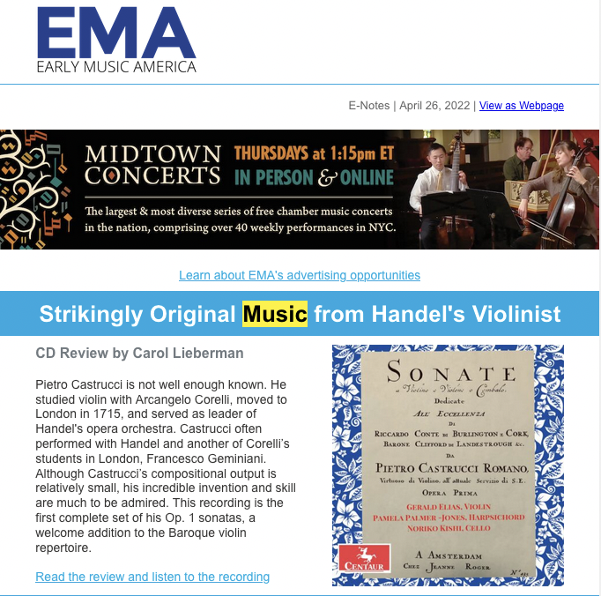
- The Strad: Resurrecting a Baroque Maverick July 2022
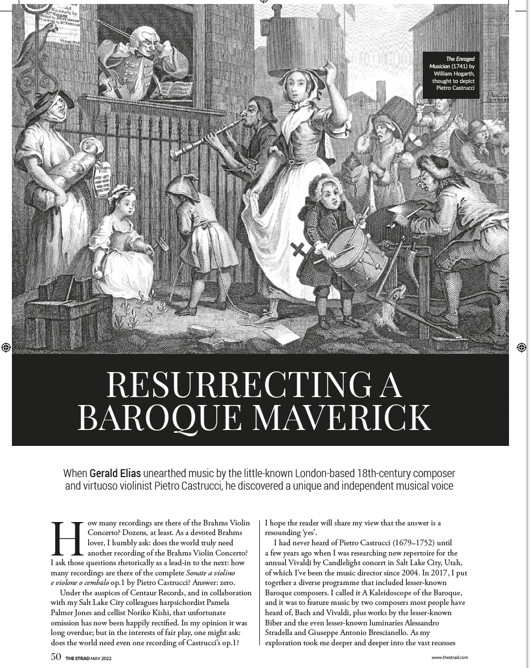
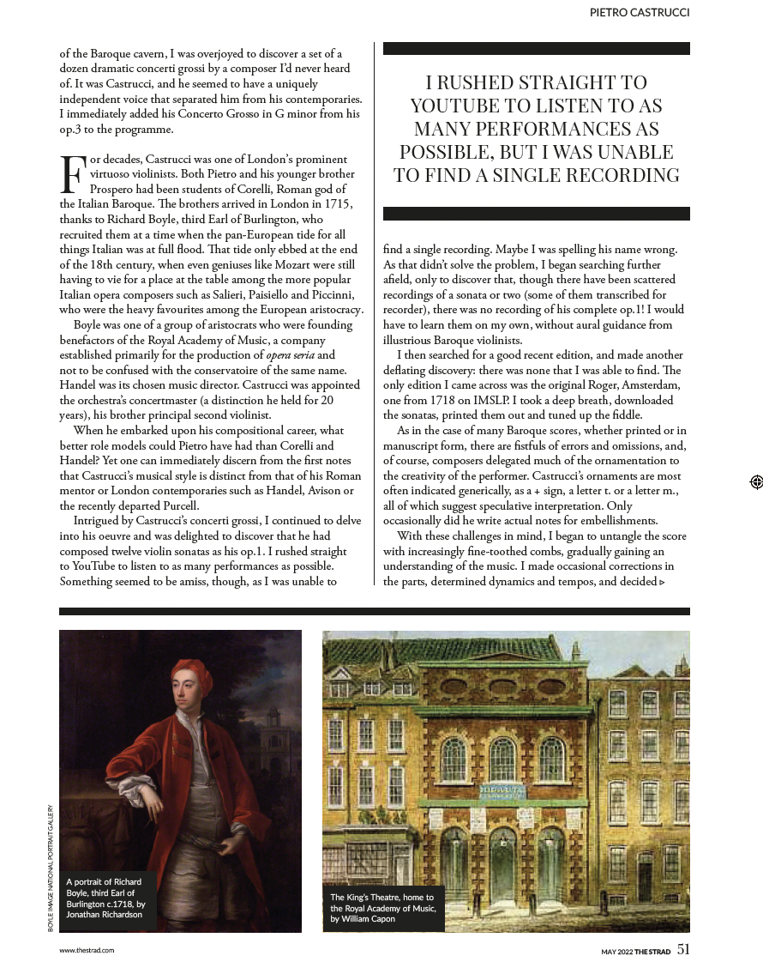
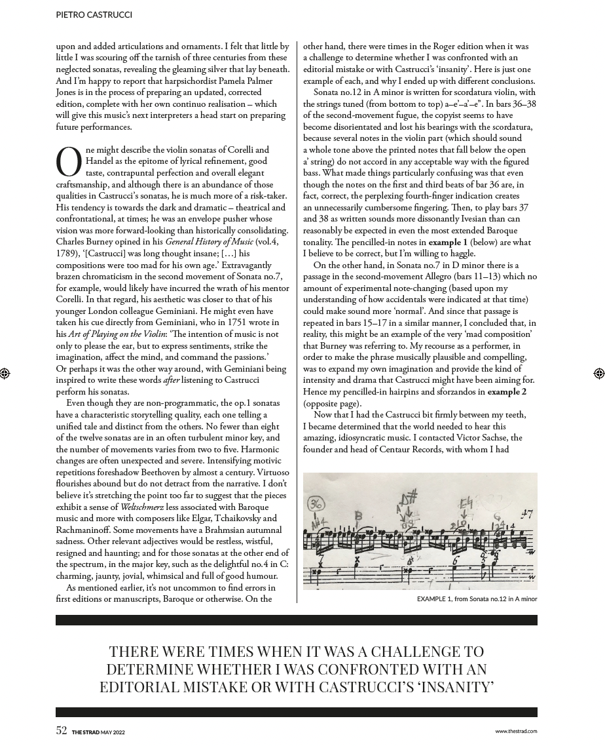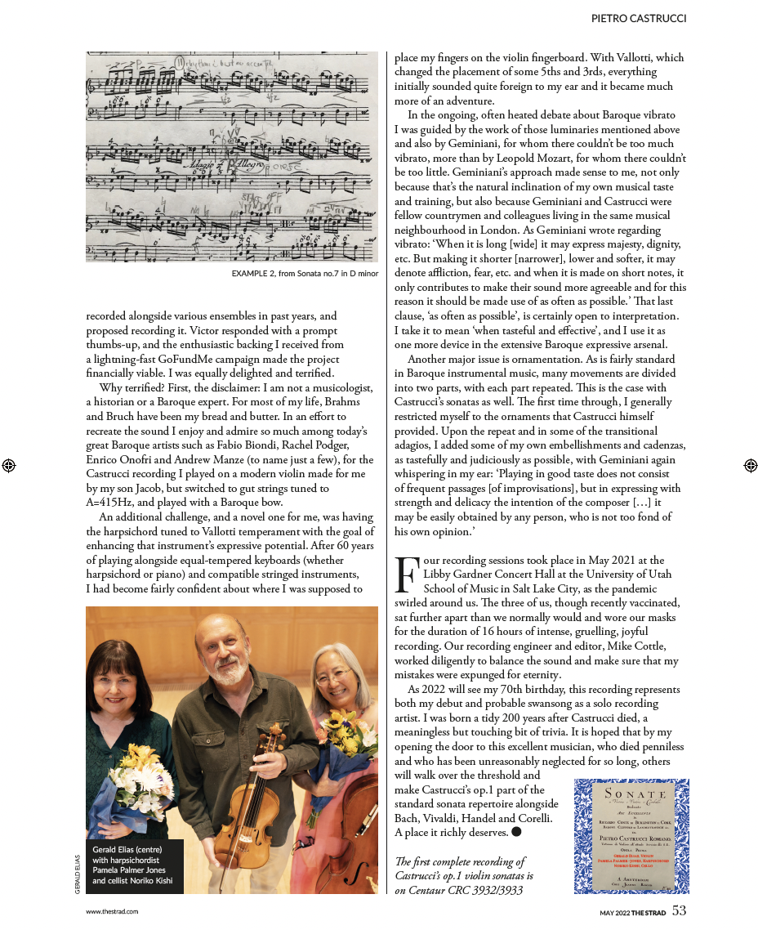
- BBC Music Magazine June 2022
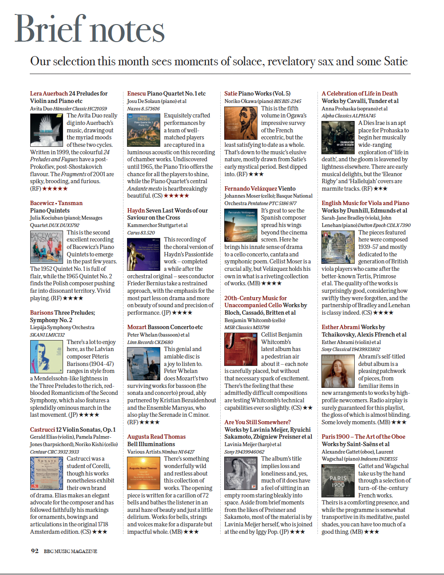
- Park City Beethoven Festival Tuning Up for its Spring Season May 2022
Finale https://www.parkrecord.com/entertainment/beethoven-festival-tuning-up-for-its-spring-season-finale/
- Early Music America: CD Review - Strikingly Original Music from April 2022
Handel's Violinist. https://www.earlymusicamerica.org/web-articles/cd-review-strikingly-original-music-from-handels-violinist/
- Early Music America 2021 Virtual Young Performers Festival. 2021
Celebrating the accomplishments of collegiate and pre-college
early music programs throughout the Americas from the 2020-2021
academic year.
https://www.earlymusicamerica.org/2021-virtual-young-performers-festival/
- Park City Beethoven Chamber Music Festival 2019
https://www.parkrecord.com/entertainment/park-city-beethoven-festival-adds-some-new- movements-to-highlight-its-37th-year/
- Vivaldi by Candlelight Concert 2019
https://youtu.be/GQoG08KWS3E

PROFESSIONAL SERVICE

MUSIC TEACHERS NATIONAL ASSOCIATION
- Honored by Utah MTA for 25 years of membership and service 2021
to the organization.
- Adjudicator for Sandy MTNA Performance Evaluations 2019
- Adjudicator for Utah MTNA Elementary Composition Competition 2018
- Adjudicator for Utah MTNA Concerto Competition, College Division 2009
- Adjudicator for Utah MTNA Performance Auditions 2012-2013
- Served on "Musical Genius Bar" at Utah MTNA State Conventions 2013-2016

NATIONAL FEDERATION OF MUSIC CLUBS
- Competition Adjudicator in Missouri, Illinois and Utah 1996- 2019

ENCORE PIANO COMPETITIONS, UTAH COUNTY
- Adjudicator for Solo and Duet Piano Competitions 2019
ENCORE PIANO COMPETITIONS, SALT LAKE COUNTY
- Adjudicator for Solo and Duet Piano Competitions at Daynes Music 2019
- Adjudicator for Solo and Duet Piano Competitions at Riverton Music 2019
SUMMERARTS PIANO COMPETITION
- Adjudicator for Solo Piano Competition 2003

SALT LAKE PIANO COMPETITION
- Adjudicator for Solo Piano Competitions, multiple divisions 2018, 2019

COMMUNITY SERVICE
- Prepared a homecooked meal for 150 cold and hungry homeless 2021
folks living under the I-15 and 7th West overpass in February.
- Violin and Piano Recital with violinist Marcela Lopez 2018
A free community service event presented at Barrio Hunter 19,
La Iglesia de Jesuchristo de Los Santos de los Ultimos Días
- Beethoven Festival Community Outreach Concerts 2015-2019
Performed numerous concerts and masterclasses at public libraries,
high schools, and care centers throughout Salt Lake and Summit
Counties (See Beethoven Festival Park City Chamber Music Festival
Facebook page for more information)
- Salt Lake Utah Inner City Mission 2015-2018
Church of Jesus Christ of Latter-day Saints. Service and humanitarian missionary with spouse Alan Jones - Barrio Hunter 19
    - The Church of Jesus Christ of Latter-day Saints 1974-2015
Pianist, organist & choir accompanist in Utah, California, New
Hampshire, Missouri, Illinois, and London, England, UK
    - Bountiful Community Church, Bountiful, Utah 2003-2006
Pianist for weekly church services
    - Zion Evangelical Lutheran Church, Salt Lake City, Utah 2003-2013
Substitute organist & choir pianist
    - Trinity Evangelical Lutheran Church, Ingleside, Illinois 1998-2002
Organist & Choir Pianist
    - Ivanhoe Community Church, Ivanhoe, Illinois 1999-2002
Substitute Organist & Choir Pianist
    - Prophet Elias Greek Orthodox Church, Holladay, Utah 1981-1983
Substitute Organist & Choir Pianist

TEACHERS AND MENTORS

UCLA
- Distinguished Lecturer Professor Johana Harris -Solo & Collaborative Piano
- Professor Bess Karp - Harpsichord
- Dr. Marie Louise Göllner - Medieval Performance Practice
- Dr. Frederic Hammond - Baroque Performance Practice
- Dr. Robert Winter - Classical Performance Practice; MFA Committee Chair
- Dr. Malcolm Cole - Romantic Performance Practice
- Dr. Elaine Barking - 20th Century Performance Practice
- Professor Samuel Krachmalnick - concerto & orchestral keyboard performance
- Dr. Paul Reale - Music Theory, Musicianship
- Dr. Irene Girton - Musicianship, Modal Counterpoint
- Visiting Professor Christopher Hogwood - Baroque Performance Practice
- Visiting Professors Paul & Eva Badura-Skoda - Classical Performance Practice

ROYAL COLLEGE OF MUSIC, LONDON, ENGLAND
- Professor John Barstow - Piano
- Professor Robert Woolley - Harpsichord, Clavichord

UNIVERSITY OF UTAH
- Dr. Susan Duehlmeier - Piano; DMA Committee Chair
- Dr. Margaret Rorke - Renaissance & Baroque Music History & DMA
Committee Member
- Dr. Steve Roens, Dr. Ning Lu, Dr. Dr. Sue Neimoyer, Dr. Eric Hinderaker,
DMA Committee members
- Professor Solveig Lunde Madsen - Piano
- Professor Gladys Gladstone - Piano
- Professor Alan Ball - Piano
- Professor Bruce Reich - Music Theory & Musicianship
- Dr. Jay Welch - Choral Accompanying
- Professor Greg Hanson - Band

ILLINOIS
- Dr. Kenneth Drake, Professor Emeritus, University of Illinois at Urbana-
Champaign - Piano, Fortepiano, Historical Performance Practice, Pedagogy
- Dr. Cathy Albergo, Department Chair, Harper College - Piano Pedagogy
- Professor Bruce Mack, College of Lake County

Accomplishments for 2021:
- Surviving Covid and managing to attend to all of my job duties, including intensive TA supervision while suffering Long Covid symptoms of severe brain fog, insomnia, depression, and severe exhaustion.
- Created Online Musicianship II course.
- Created Online Theory 2 course
- Castrucci project: recording, music editing, CD published by Centaur, raising $5000 on Facebook + UTG ($2500) & URG ($5100), creating performing edition. Recorded on May 10, 12, 17 & 19, 2022, while my mother was in the ICU with Covid, and I was taking care of my disabled father at night.
- Creating pedagogical performance practice videos
- Facilitated the donation of a practice harpsichord from the Cannon Family Trust to the SOM - January 2021
- Helped feed the homeless by preparing meals for 125 folks living under the underpass
- Was awarded a Dee Grant as co-sponsor with Vedrana Subotic for Christopher O'Reilly (awarded in 2021, happening in Jan-March 2022)
- Member of College Council/Career Line Rep
- My recording of Detorri's "Lady Gaga Fugue" featured on April 1 on KBYU
- Member of Dan White's doctoral committee; read his paper, attended all recitals, then was replaced by a choral member of the committee
- Collaboration between 7210 & Early Music Ensemble submission to EME Young Performers - one of 14 groups accepted worldwide into the online eFestival
- Became a member of the College of Adjudicators for the Royal College of Music, Canada. Sept 2021
- Beethoven Festival Park City concert performances on June 22 (Salt Lake City), June 25 (in Capital Reef National Park), June 30 (Salt Lake City), August 2 (Park City), August 8 (Park City), August 26 (Park City)
- Ka-Wai Yu collaboration with Luke Dahn in October - recorded pedagogical videos and did a performance Oct. 14-17, 2021
- Honored by Utah MTA for 25 years of membership and service to the organization - Nov 5, 2021
- Saturday Afternoon Baroque: The Italian-German Connection with colleague Lisa Chaufty and guest artists Susanne Stump and Daniel Ryan - November 13, 2021
- Faculty Showcase Recital on Nov 17, 2021 with colleagues Kasia Sokul-Borup and Lisa Chaufty at the Museum of Fine Arts
- Harpsichord coach for Early Music Concert: Musical Journeys through Time and Place on December 4, 2021 in Thompson chamber Hall.
- Harpsichordist for Vivaldi by Candlelight Concert at 1st Presbyterian Church - December 4, 2021
- Recorded pedagogical videos with Gerald Elias as part of the Castrucci Project - Dec. 5, 2021 in Libby Gardner Hall
- Sundays@7 Faculty Showcase Recital (Corelli "Christmas" Concerto) on Dec. 10, 2021 in Libby Gardner Hall
- Salt Lake Symphony concert (piano/celeste/harpsichord) on Dec. 18, 2021 in Libby Gardner Hall.
- Having online zoom faculty meetings is amazing - keep doing this

