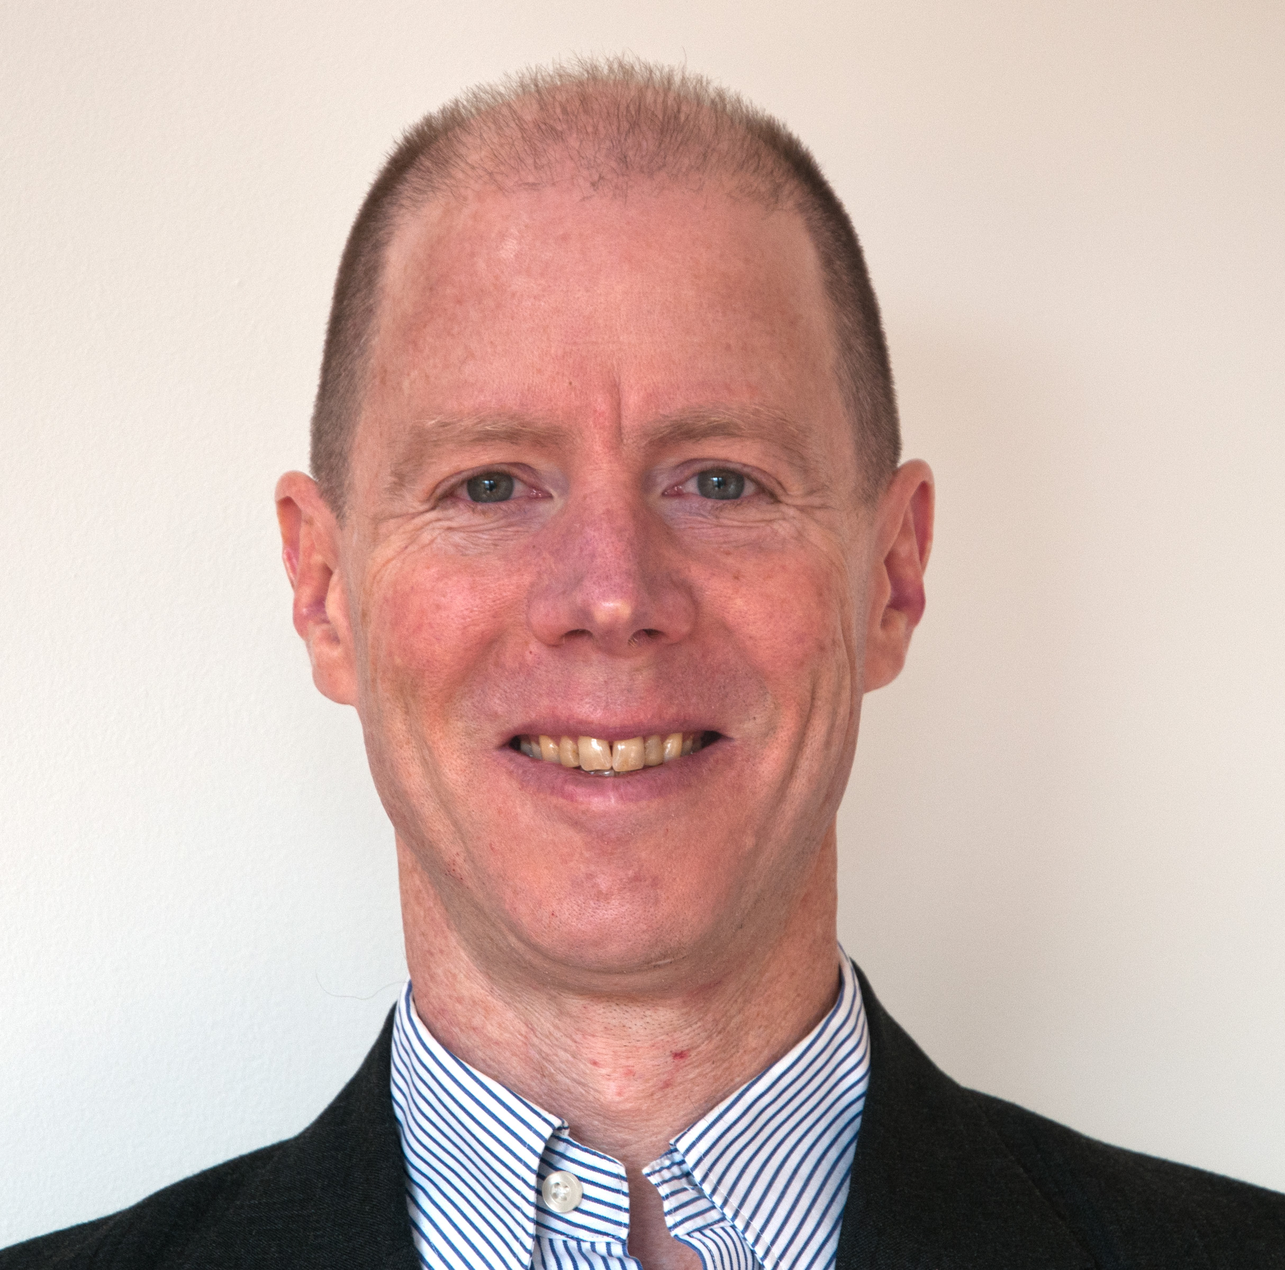
Professional Biography
Prof. Robert Parker
Department of Mechanical Engineering
University of Utah
rgp.dynamics@gmail.com (for consulting)

Prof. Parker is in the Mechanical Engineering Department at the University of Utah. Previously he was Department Head at Virginia Tech and Executive Dean at the University of Michigan-Shanghai Jiao Tong University Joint Institute. He served 13 years on the faculty at Ohio State. He received MS and PhD degrees from the University of California, Berkeley.
Prof. Parker’s expertise is in mechanical systems, with focus on vibration, dynamics, noise, failure, stress/strain, fault diagnosis, and design. He has consulted for numerous multi-national companies to address problems in the automotive, helicopter, aircraft engine, wind turbine, and power generation fields. In these cases, models and methods developed in his research have been instrumental in solving major problems with economic impact exceeding $100M.He has delivered over 100 keynote and invited lectures. He has published extensively, and the extensive citation of his papers by others (roughly 11,000 citations) marks his work as among the most influential in the field.
Prof. Parker has consulted extensively on legal cases since 2009, including all of patent invalidity, patent infringement, and class action litigation. He has been formally deposed, given oral courtroom testimony, and prepared written declarations numerous times for cases in the US, Germany, European Patent Office, Chinese Patent Office, and Chinese trial courts. The side that Prof. Parker supported was won, or reached favorable settlements in, each of the cases where he has been involved.
Prof. Parker is a Fellow of the American Society of Mechanical Engineers (ASME), the American Association for the Advancement of Science, and the International Institute of Acoustics and Vibration. He received the 2015 ASME N. O. Myklestad Award for “major innovation in vibration research and engineering.” He has received the US Presidential Early Career Award for Scientists and Engineers (“…the highest honor awarded by the US government to scientists and engineers early in their independent research careers”), the National Science Foundation CAREER, and the US Army Young Investigator Awards, as well as the ASME Gustus Larson Award, Ford Chief Engineer Award, French government Poste Rouge Award, SAE Ralph Teetor Educational Award, ASEE’s Global Engineering Educator and Outstanding Faculty Awards, and five separate research awards from Ohio State University.
He serves on the Editorial Board of the Journal of Sound and Vibration. He previously served on the Editorial Board for Mechanism and Machine Theory, and served seven years as Associate Editor for the ASME Journal of Vibration and Acoustics.
Prof. Parker has been a Visiting Fellow at Polytechnic University of Turin, Risoe National Lab (Denmark), the University of New South Wales, the University of Sydney, Tokyo University, NASA Glenn Research Center, and INSA Lyon.

